Unit 9
Descriptive Quantitative Analysis

- Introduction

Over recent years there has been a move to evidence based decision making. To do this effectively business must collect numerical data, store it and interrogate it. In this unit an overview of some statistical techniques that you could well find useful in your research. The unit begins with a review of basic statistical summaries; frequencies, bar charts and numerical measures and then tables are reviewed and an example of a scatter plot is given. Then covered is the unit is the use of t-tests to compare two groups and analysis of variance (ANOVA) to compare more than two groups. These are tests for continuous data. This unit concludes with how to test for association between categorical forms of data.

Examples of how to conduct the analysis is given in EXCEL – which is not a very flexible package to analyse the data in. A more user friendly and popular statistical analysis software package is SPSS and you can visit SPSS website on www.spss.com see also Bryman and Crammer, 2004. A useful book to consult is “Doing Statistics with EXCEL” by M. K. Pelosi and T. M. Sandifer, published by John Wiley & Sons, Chichester, 2002. For example a bank has stored data, in the Microsoft package EXCEL, on the starting salary, current salary, number of year of education, age, gender, job category and number of years of employee service for each of its 474 employees. This file is called employ.xls and is available on the web page for the module.

Types of variables and their measurements were discussed in previous units. However, to generate data we must need sufficient knowledge about coding and recoding of variables. This job is little tedious for the primary sources of information, on the other hand, it is relatively easy for secondary sources. For primary sources, we need sufficient editing responses before entering into computer data file. By definition editing is the process of checking and adjusting the data for omissions, legibility, and consistency.
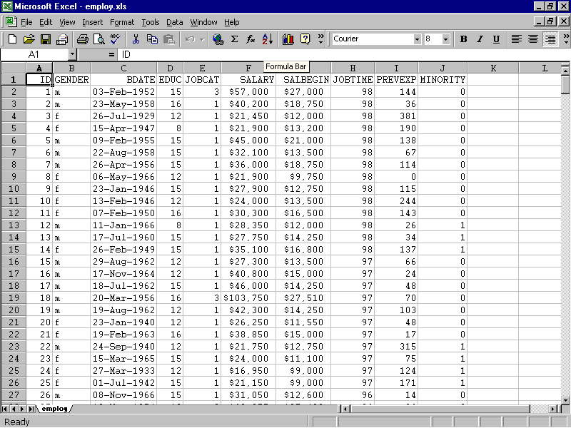

Each of these entities in the above table is called variable. There are two types of variables continuous – which are entities that can be measured on a continuous scale – like age and salary. The other form of variables are categorical which can be divided into ordinal in which the level of the category – like social class and nominal which are variables whose class is arbitrarily assigned a class such a car colour or gender. For the categorical variable job category 1 is the code for a clerical worker, 2 is for custodial and 3 is for managerial. Minority is an example of another categorical variable where 0 stands for not in a minority and 1 is a minority group.

- Descriptive statistics

Descriptive statistics help us to understand and summarise the data. The summary statistics can either be represented by tabular form or by graphically. These useful tools are briefly discussed here.

- Frequency and Frequency distribution
Frequency is the count of each category in a certain variable. This count is often expressed as a percentage form or cumulative percentage form. For example, if we wish to know how many of each gender are employed by the bank – following analysis can be used. In EXCEL click on Data then PIVOT TABLES.

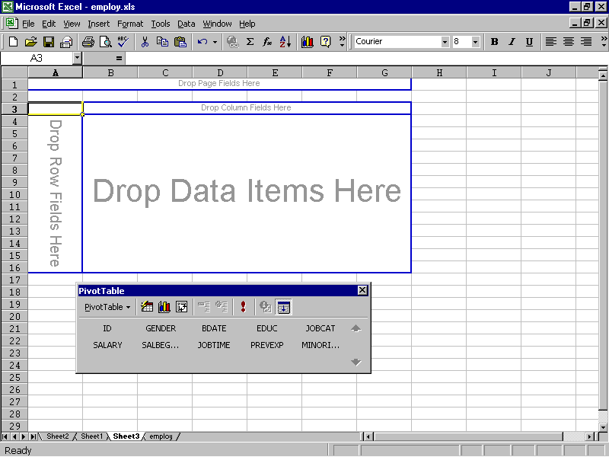

Move GENDER to column fields and also on to “Drop Data Items Here”. In gender variable ‘m’ stands for male and ‘f’ for female. This gives counts:

Count | GENDER
 | f | m | Grand Total
Total | 216 | 258 | 474

To get percentages click on “Count of Gender” and click on “Options” then in the show as field request row percentages – this gives:

Percent Count | GENDER
 | f | m | Grand Total
Total | 45.57 | 54.43 | 100.00

For employment category (in percent)

JOBCAT
1 | 2 | 3 | Total
54.26 | 8.07 | 37.67 | 100.00

This can be represented by a bar chart:

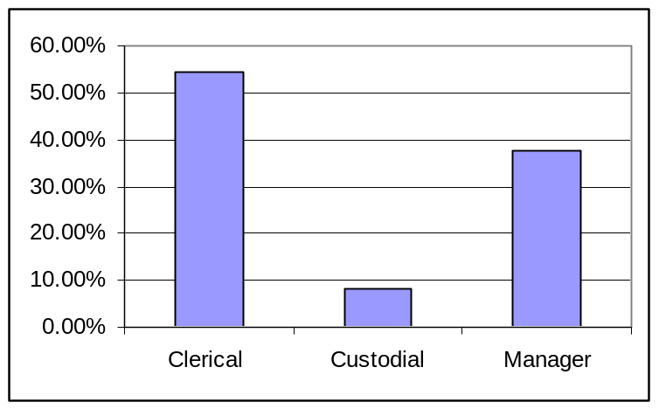

A clustered bar chart allows one to see the distribution of job type by gender. To do this first get the two way table:

Sum of JOBCAT | JOBCAT
GENDER | 1 | 2 | 3 | Row Total
f | 87.29% | 0.00% | 12.71% | 100.00%
m | 36.26% | 12.47% | 51.27% | 100.00%
Column Total | 54.26% | 8.07% | 37.67% | 100.00%

This was formed from pivot table with jobcat as columns and in the centre of the table and gender as rows. We then requesting for row percents. Then use the chart wizard to get:

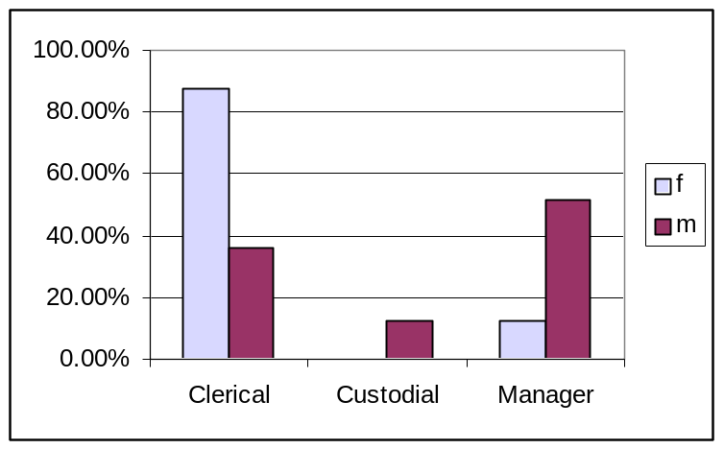

What does this tell you about male and female employment in the bank?

- Measures of Location and Spread

To summarise continuous data one quotes the most representative number usually the average or mean (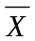) and the median and measures of dispersion around the mean.

Consider the following set of numbers

7 5 2 5 8 6 4 3 5

The mean is the sum of the numbers divided by the number of numbers i.e. 45/9 = 5

If one arranges the numbers in order of size, the median is the middle number.

2 3 4 5 5 5 6 7 8

And do in this case the mean is also 5.

Linked to the median are quartiles these split the number string in to 4 groups. In the above example the lowest quartile is at 3.5 the middle quartile is the median and the upper quartile is at 6.5.

A measure of spread is the range which is the difference between the maximum and minimum number i.e. 8 –2 = 6.
A measure of spread which is not distorted by extremes is the interquartile range which is the difference between the upped quartile and the lowest quartile i.e. 6.5 – 3.5 = 3.
A widely used measure is the standard deviation (s) which is given by the following formula:
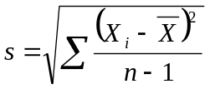
7 5 2 5 8 6 4 3 5
The computation is displayed in the following table:

X_{i} | 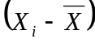 | 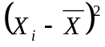
7 | 2 | 4
5 | 0 | 0
2 | -3 | 9
5 | 0 | 0
8 | 3 | 9
6 | 1 | 1
4 | -1 | 1
3 | -2 | 4
5 | 0 | 0
= 5 |  | Sum = 28
 |  | s² = 3.5, s = 1.87

The square of the standard deviation is known as the variance.
The bigger the standard deviation the more variable or dispersed the data is and it is a basic tool used for measuring the spread within individual variables.
To conduct this analysis in EXCEL go to TOOLS and then DATA ANALYSIS, (this may need to be added in - ADD INS then analysis tool pack). Then go to descriptive statistics and enter the range of the data.

A summary of the current salary is

SALARY
Mean | 34419.57
Standard Error | 784.31
Median | 28875
Mode | 30750
Standard Deviation | 17075.66
Sample Variance | 291578214
Kurtosis | 5.378
Skewness | 2.12
Range | 119250
Minimum | 15750
Maximum | 135000
Sum | 16314875
Count | 474

Let us only concern ourselves with the mean, median and standard deviation.

A graphical summary of this data is the histogram:

To create this first define a “bin range” in an empty column. This is the range of salaries – in the data set I have put this in column k.

Go to Data Analysis and request Histogram – enter the appropriate fields i.e. f2:f475 and k2:k12 – this gives a bin and frequency column – from which you can create a column chart. It is conventional not to have spaces between the columns – this is achieved by clicking on the column and then “options” and reducing the space between columns to zero.

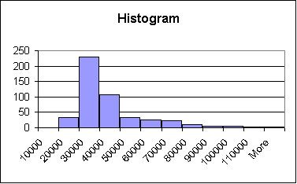  Bin | Frequency
10000 | 0
20000 | 33
30000 | 230
40000 | 107
50000 | 33
60000 | 26
70000 | 22
80000 | 10
90000 | 4
100000 | 5
110000 | 2
More | 2

This is a skewed distribution and often one may wish to make the distribution more symmetrical or normally shaped. This can be done by taking natural logarithms of the current salary. This is done by using the formula =ln(f2) – see column L in the EXCEL spreadsheet.

If one wishes to compare male and female salaries the above statistics can be used. To do this fist, sort the salaries into males and females by going to data and sort by gender. Then use “Descriptive Statistics” twice to obtain the following:

Female |  | Male
Mean | 26031.92 | Mean | 41441.78
Standard Error | 514.26 | Standard Error | 1213.97
Median | 24300 | Median | 32850
Mode | 24450 | Mode | 30750
Standard Deviation | 7558.02 | Standard Deviation | 19499.21
Sample Variance | 57123688 | Sample Variance | 3.8E+08
Kurtosis | 4.64 | Kurtosis | 2.78
Skewness | 1.863114 | Skewness | 1.64
Range | 42375 | Range | 115350
Minimum | 15750 | Minimum | 19650
Maximum | 58125 | Maximum | 135000
Sum | 5622895 | Sum | 10691980
Count | 216 | Count | 258

To graphically compare groups boxplots are helpful. Boxplots are part of a set of techniques called exploratory data analysis of EDA – some of these techniques are outline in the appendix at the end of these notes. These techniques are not available in EXCEL.
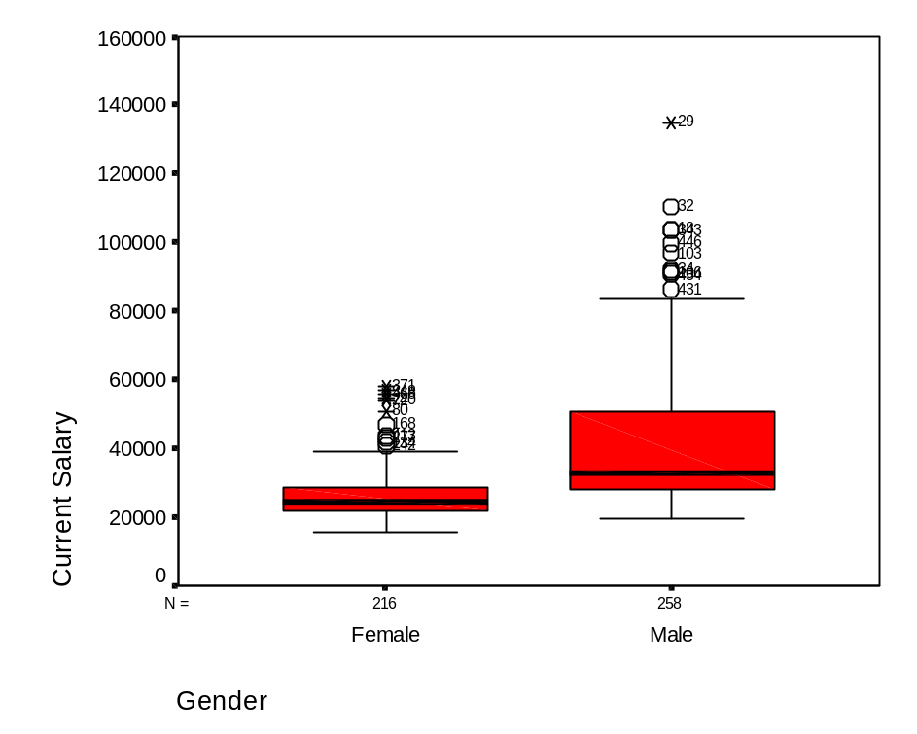

Thus males are paid more and the salaries are more variable. Pivot tables can also be used to get means, medians and standard deviations. If one puts job category as columns, gender as rows and salary in the table one obtains:

Average of SALARY | JOBCAT
GENDER | Clerical | Custodial | Manager | Grand Total
f | 25003.69 | - | 47213.50 | 26031.92
m | 31558.15 | 30938.89 | 66243.24 | 41441.78
Grand Total | 27838.54 | 30938.89 | 63977.80 | 34419.57

To change the statistic which is displayed in the table click on the first cell (topmost corner) which appears in the pivot table. Initially this appears as Sum of Salary.

3. Scatter Plots

To examine how one continuous variable may depend on another – plots are useful. For example to examine if salary is related to years of education a simple scatter plot is helpful. This is available in chart wizard and is called a X-Y plot.

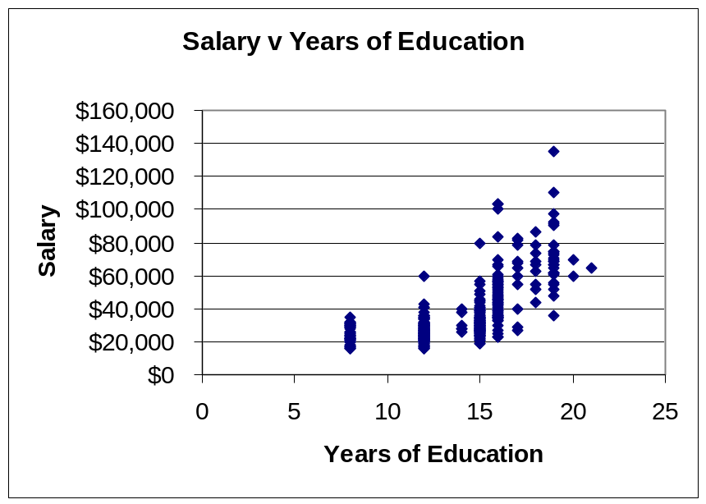

Thus it appears that the more years of education is generally associated with greater salary.

4. More on Tables

Tables are often ignored but they are extremely useful data summaries and analysis tools.

e.g. British Oil’s coal sales, in thousand tonnes, for its major markets in 1991 were:

USA 13,526; Germany 2,272; Rest of Europe 2,501; South Africa 3,514; Australia 4,505.

Using the above Data answer the following:

- Which region was the largest coal market?
- Which region was the smallest market for coal?
- What is the difference in coal sales between Australia and the Rest of Europe?
- What is the total coal sale?

These questions are easily answered if the data is displayed in a table.

British Oil

Coal Sales by Market for 1991
(Sales are shown in thousand tonnes)

Market | Coal Sales
USA | 13,256
Australia | 4,505
South Africa | 3,514
Rest of Europe | 2,501
Germany | 2,272
Total | 26,048
Source: Annual Company Report British Oil 1992.

Consider the following table:

Distribution of Annual Income, (in thousands), Selected by Sex and Age

 |  | Age
Gender | Parameter | 16-20 | 21-30 | 31-40 | 41-50 | 51-60
Male | Number | 20 | 60 | 40 | 30 | 20
Male | Mean | 7 | 15 | 24 | 27 | 33
Male | St Dev | 1.3 | 3 | 5 | 6 | 8
Female | Number | 15 | 50 | 40 | 22 | 18
Female | Mean | 6 | 12 | 18 | 20 | 10
Female | St Dev | 1.4 | 3 | 5 | 6 | 6

What do you conclude from this table and what other information is required?

Another table could be the log of experimental results of yields produced at different temperatures:

 | Temperature
Pressure Level | 1 | 2 | 3 | 4 | 5 | 6 | 7 | 8
9 | 38 | 42 | 50 | 50 | 50 | 48 | 45 | 40
8 | 50 | 53 | 56 | 58 | 63 | 58 | 50 | 45
7 | 70 | 74 | 77 | 80 | 85 | 80 | 70 | 60
6 | 79 | 80 | 83 | 85 | 95 | 90 | 70 | 67
5 | 79 | 85 | 90 | 95 | 99 | 90 | 75 | 72
4 | 75 | 86 | 90 | 94 | 96 | 88 | 75 | 70
3 | 67 | 80 | 85 | 92 | 94 | 90 | 75 | 67
2 | 62 | 75 | 80 | 87 | 89 | 85 | 70 | 66
1 | 55 | 68 | 74 | 84 | 86 | 80 | 70 | 65

Coding makes tables easier to interpret.

In this case use the transformation of divide by 10 and subtract 7 to get:

Temperature Level

Pressure Level |  | 1 | 2 | 3 | 4 | 5 | 6 | 7 | 8

9 |  | -4 | -3 | -2 | -2 | -2 | -2 | -2 | -3
8 |  | -2 | -2 | -1 | -1 | -1 | -1 | -2 | -2
7 |  | 0 | 0 | 1 | 1 | 2 | 1 | 0 | -1
6 |  | 1 | 1 | 1 | 2 | 3 | 2 | 0 | 0
5 |  | 1 | 2 | 2 | 3 | 3 | 3 | 1 | 0
4 |  | 1 | 2 | 2 | 2 | 3 | 2 | 1 | 0
3 |  | 0 | 1 | 2 | 2 | 2 | 2 | 1 | 0
2 |  | -1 | 1 | 1 | 2 | 2 | 2 | 0 | 0
1 |  | -1 | 0 | 0 | 1 | 2 | 1 | 0 | 0

One can take a pencil and join numbers of the same level – this produces contours and one can determine that the best operating range is temperature level s 4 to 6 and pressure levels 4 to 6.

Tabular Analysis: As an example consider infant mortality by year and social class.

 | IMPORT
 | CLASS
YEAR | 1.00 | 2.00 | 3.00 | 4.00 | 5.00
1911  1921  1930-32  1939  1945-50 | 55.00  38.00  32.00  26.00  18.00 | 98.00  55.00  45.00  34.00  21.00 | 125.00  78.00  57.00  44.00  28.00 | 125.00  89.00  66.00  51.00  34.00 | 152.00  97.00  77.00  60.00  39.00

Median Polishing
First remove row medians and then column medians.
Row Medians
125 | -70 | -27 | 0 | 0 | 27
78 | -40 | -23 | 0 | 11 | 19
57 | -25 | -12 | 0 | 9 | 20
44 | -18 | -10 | 0 | 7 | 16
28  Column Medians | -10 | -7 | 0 | 6 | 11
57 | -25 | -12 | 0 | 7 | 19
68 | -45 | -15 | 0 | -7 | 8
21 | -15 | -11 | 0 | 4 | 0
0 | 0 | 0 | 0 | 2 | 1
-13 | 7 | 2 | 0 | 0 | -3
-29 | 15 | 5 | 0 | -1 | -8

The boxed number is the column median of the row medians and is referred to as the common effect.
(data)_{ij} = common + row effect_{i} + column effect_{j} + 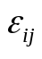

e.g. 55 = 57 + 21 - 12 - 11

The median infant mortality rate is 57 can see social class and year effects. Residuals are generally smaller than the effects. Converting the information to graphical presentations is very useful. Thus infant mortality has decreased over time and the social class differentials have narrowed.

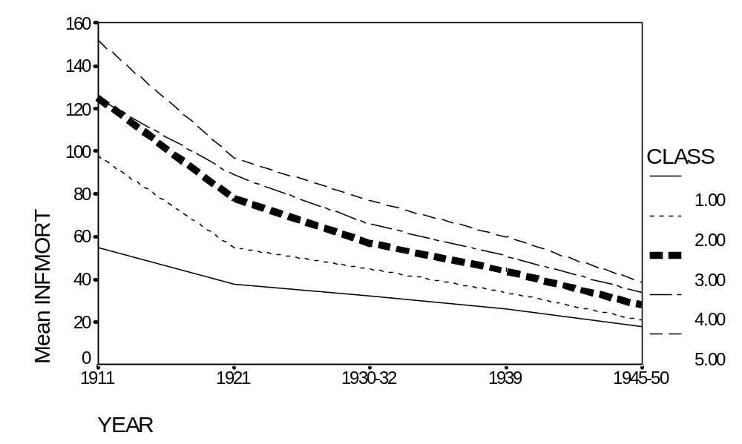

Questionnaires and Tables

Consider a situation in which 100 males and 50 females were asked to rate their views on nuclear energy on a five point scale from very bad to very good. The distribution might be:

 | Very Bad | Bad | Neutral | Good | Very Good
Males | - | 20 | 30 | 40 | 10
Females | 20 | 10 | 10 | 10 | -

Computing row percents makes the analysis easier

 | Very Bad | Bad | Neutral | Good | Very Good
Males | 0 | 20 | 30 | 40 | 10
Females | 40 | 20 | 20 | 20 | 0

If one thinks of the scale of very bad to very good being coded as the following weights:

-2 -1 0 1 2

If for both males and females the percent responses are multiplied by these weights and summed one gets the following nominal scores:

Male Nominal Score: -2*0 +(-1)* 20 + 0 + 40 + 2*10 = 40

Female Nominal Score: -2*40 + (-1)*20 + 0 + 20 + 0 = -80

Thus there is a clear difference between males and females. Consider the questions associated with factors which influence the use of the internet. Subjects might have been asked to complete the following questions:

 | View
Item | 1 Very unimportant | 2 | 3 Neutral | 4 | 5 Very important
Work
Home
Games
E-Mail
Study
Research
Leisure
Other

The counts and distribution of those who answered this question is displayed in the following table. The average response is also worked out and appears in the last column.

 | View
Item | 1 | 2 | 3 | 4 | 5 |  | Average (mean)
Work | 0 | 2 | 4 | 17 | 12 |  | 4.11
Home | 0 | 3 | 17 | 6 | 9 |  | 3.60
Games | 7 | 14 | 5 | 6 | 13 |  | 3.09
E-Mail | 0 | 1 | 5 | 9 | 20 |  | 4.37
Study | 5 | 5 | 16 | 5 | 4 |  | 2.94
Research | 6 | 7 | 17 | 3 | 2 |  | 2.66
Leisure | 0 | 5 | 6 | 11 | 13 |  | 3.91
Other | 5 | 14 | 9 | 4 | 3 |  | 2.60

From this a column chart of the averages can be obtained:

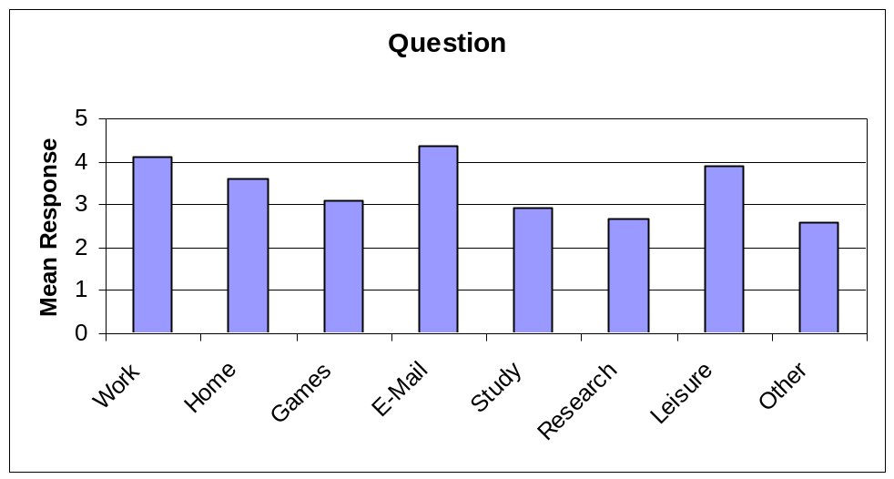

Guidelines for the Production of Tables

- The table must have a clear purpose.

- The table must have an explanatory title

- The table must clearly indicate the units of measurement of the data

- the table should clearly indicate the source of the data

- Lines should be drawn where appropriate to draw attention

- Row and column totals should be shown where meaningful

- Percentages and ratios should be computed if appropriate

- Don’t present too many significant digits

- It is easier to look down a column of numbers than across a row

- Give attention to the spacing and layout of the table.

- Are there Significant Differences?

Here one asks is there a significant difference between a group of sample measurements and a value. For example in a statistical quality improvement situation, suppose in the manufacture of circuit boards that a critical dimension is 80 microns. If a sample, of 5 circuit boards, is measured the measures might be 81, 79, 76, 70 and 77 microns. The average of this sample is 76.6 microns. Is this a big enough difference from the target of 80 to say that the process is not meeting the target? To confirm this, another sample could be taken giving the results 78, 82, 88, 85 and 85 microns – giving an average of 83.6 microns – now what is to be concluded. Consider 100 samples of size five, which gives the distribution of averages from the sample of:

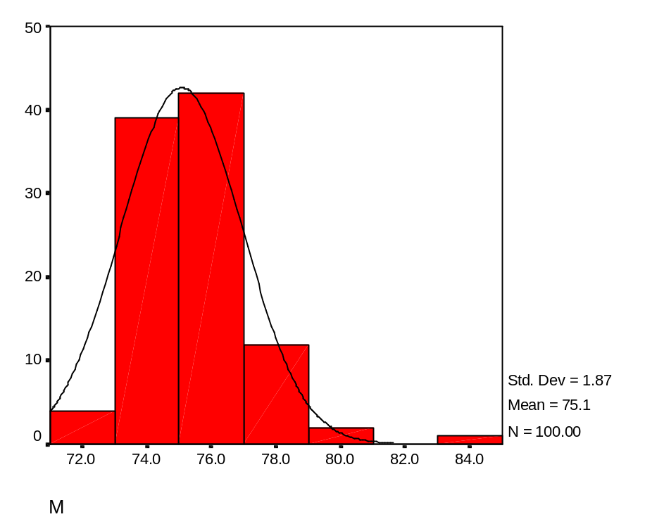
The smooth curve is said to be the Normal Distribution - which theoretically a distribution of averages would lie. The mean of all these samples is 75.1 and 95% of the data lies between 74.7 and 75.5 microns. This is often referred to as the 95% Confidence Interval of the mean. One is 95% sure that the mean lies in this interval. The target of 80 does not lie in this interval so it is concluded that the process is not conforming to target and it is significantly less than 80 microns. It appears that the second sample is significantly different from the rest of the data – as is apparently clear from the above histogram.

Theoretically for any sample the equation that gives the 95% Confidence interval is:

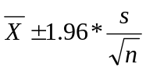
Where s is the standard deviation a measure of variability and n is the size of the sample. Thus as the variability increases and n decreases the confidence interval widens.

For a sample of five readings the fist set has a confidence interval of 71.44 to 81.76 with a mean of 76.60 microns. While the second sample has a confidence interval of 78.9 to 88.30 with a mean of 83.60 microns. These confidence intervals overlap and so the two samples are said to not be significantly different.

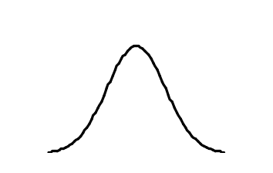

Sample 1

Sample 2

71 72 73 74 75 76 77 78 79 80 81 82 83 84 85 86 87 88 89 90

When a target is not included in the confidence interval then there is said to be a significant difference – likewise if the two confidence intervals were not to overlap then they would be significantly different.

If the confidence interval just bordered the target or another confidence interval then one would be 97.5% sure that there is a difference. – why?

Often these ideas are quoted as P-values – which is the likelihood of a difference occurring by chance – if this is less than 5% (0.05) then this is taken as an acceptance of significance. (In SPSS the P-value is called the sig level.)

Formally one tests a null hypothesis (H_{o}) that there is no difference to an alternative hypothesis (H_{a}) that there is a difference.

i.e. H_{o} : There is no significant difference.
v
H_{a} : There is a difference (note there are three forms of this test).

Comparing against a target

Here a one sample t-test is used which is available on the descriptive analysis section in EXCEL.

For example using the data in the file employ.xls one can ask the question is the average years of education is more than 10?

H_{o}: The mean is not different from 10.
V
H_{a}: The mean is greater than 10.

To choose which hypothesis to accept a one sample t – test is used. Essentially a confidence interval is constructed and if the test value is in that interval then accept H_{o.} Unfortunately EXCEL does not readily execute the one sample t – test It does do two sample t-tests, which are available in the data analysis menu. This can be used by putting a column of zero’s to compare with the variable of interest (years of education) at stating the level of difference from 0 – which in this case is 10.

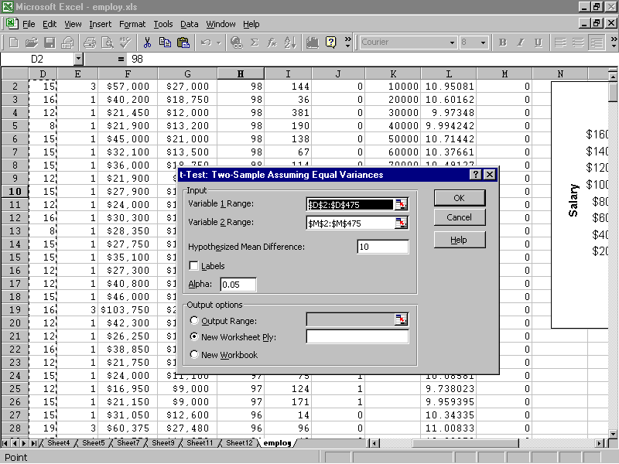
This gives:
Because P(T<=t) is less than 0.05 one accepts H_{a} and that the mean years of education is greater than 10. | Variable 1 | Variable 2
Mean | 13.49 | 0
Variance | 8.32 | 0
Observations | 474 | 474
Pooled Variance | 4.16
Hypothesised Mean Difference | 10
df | 946
t Stat | 26.35
P(T<=t) one-tail | 1.7E-115
t Critical one-tail | 1.65
P(T<=t) two-tail | 3.4E-115
t Critical two-tail | 1.96

Accept the alternative hypothesis as the p value is less than 0.05 – so 95% sure that the mean is greater than 10.

- Comparing two groups

Here a two samples t-test is used – there are two types one when the variance (standard deviation squared) between the groups is broadly similar and the other when the variances are not. A rule for deciding this is if the ratio of the standard deviation squared to the other standard deviation squared is greater than 2 then use the unequal variance version. In practice it does not make much difference which one is used.

For example are men paid more than females? – For these t-tests one requires data that is roughly symmetrical so in this case it is best to use natural logarithms of the salary data.

Formally test

H_{o}: the salary is not affected by gender.
V
H_{a}: males are paid more than females.

To use the t – test first sort the data set by gender and compute the standard deviations of log salary for each group and square these deviations.
This gives the ratio 0.159/0.065 = 2.46 so use unequal variance version of the t-test.

The output then is:

t-Test: Two-Sample Assuming Unequal Variances
As p is less than 0.05 reject the null hypothesis and conclude that there is a difference
 | Variable 1 | Variable 2
Mean | 10.13 | 10.54
Variance | 0.065 | 0.159
Observations | 216 | 258
Hypothesised Mean Difference | 0
df | 442
t Stat | -13.63
P(T<=t) one-tail | 7.38E-36
t Critical one-tail | 1.65
P(T<=t) two-tail | 1.48E-35
t Critical two-tail | 1.97

Paired Comparisons

This is used to compare two groups which only differ by one intervention.

For example, the performance of 12 individuals before and after a training intervention:

Individual | 1 | 2 | 3 | 4 | 5 | 6 | 7 | 8 | 9 | 10 | 11 | 12
Before | 55 | 61 | 47 | 65 | 58 | 57 | 55 | 50 | 65 | 61 | 60 | 55
After | 60 | 68 | 53 | 60 | 70 | 63 | 53 | 58 | 68 | 64 | 60 | 69

H_{o}: Training makes no difference to performance.
V
H_{a}: Training improves performance.

Using the paired samples t- test in the data analysis menu gives:

t-Test: Paired Two Sample for Means
 | Variable 1 | Variable 2
Mean | 57.42 | 62.17
Variance | 29.90 | 34.52
Observations | 12 | 12
Pearson Correlation | 0.54
Hypothesised Mean Difference | 0
df | 11
t Stat | -3.02
P(T<=t) one-tail | 0.01
t Critical one-tail | 1.80
P(T<=t) two-tail | 0.01
t Critical two-tail | 2.20

Thus as p is less than 0.05 one can conclude that training has improved performance.

- Comparing more than two groups

To compare more than two groups One Way Analysis of Variance (ANOVA) is used.

For example does educational level vary significantly with job grade?

H_{o}: there is no difference between the educational level with job grade.
V
H_{a}: there is a difference with job grade and educational level.

First sort the data by job grade and copy years of education associated with people in the different job grades into three consecutive columns in a new worksheet (see ANOVA in employ.xls). Then go to data analysis, then request ANOVA single factors and enter the data ranges.

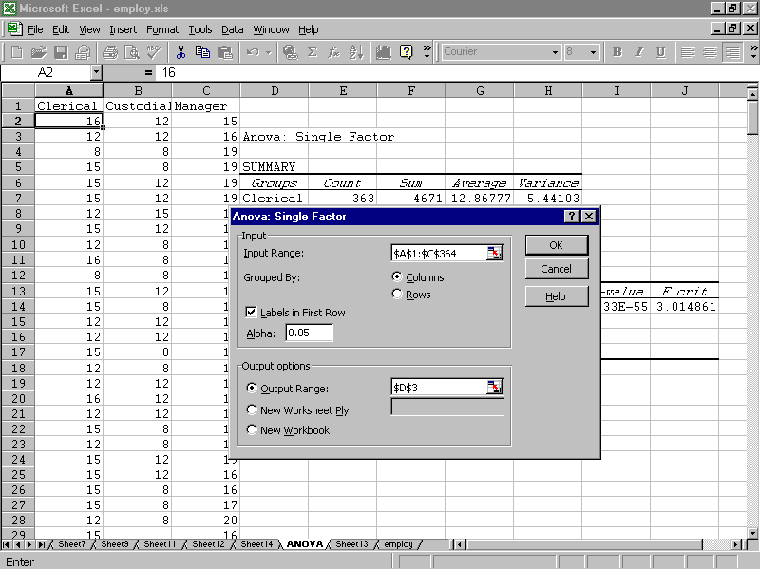

This gives:

Anova: Single Factor
SUMMARY
Groups | Count | Sum | Average | Variance
Clerical | 363 | 4671 | 12.87 | 5.44
Custodial | 27 | 275 | 10.19 | 4.93
Manager | 84 | 1449 | 17.25 | 2.608
ANOVA
Source of Variation | SS | df | MS | F | P-value | F crit
Between Groups | 1622.99 | 2 | 811.49 | 165.2119 | 4.33E-55 | 3.01
Within Groups | 2313.48 | 471 | 4.91
Total | 3936.47 | 473

This shows as the p value is less than 0.05 that the alternative hypothesis should be accepted and that there is a significant difference in the years of education of employees in different job grades. Managers have the most years of education, followed by clerical workers.

- The Association between Categorical Variables

To undertake these tests Contingency Tables and Chi-square (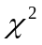) Analysis is used.

For example if one was to enquire into the regional distribution of wither or not development grants are awarded, one may have produced the following table:

Region | Application Successful | Application Rejected |  | Row Totals
North | 63 | 299 |  | 362
East | 55 | 207 |  | 262
West | 44 | 208 |  | 252
South | 54 | 169 |  | 223

Column Total | 216 | 883 |  | 1099

One wishes to test for association between columns (accept or reject) and the rows (region), i.e.:

H_{o}: there is no association.
V
H_{a} : there is an association.

The expected distribution if the values in the table were distributed proportionately. The expected value is computed from:

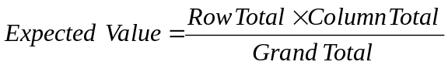
So for North, the expected value is 71.5 = (362*216)/1099
Putting the Expected Values in brackets the above table becomes:

Region | Application Successful | Application Rejected |  | Row Totals
North | 63 (71.15) | 299 (290.85) |  | 362
East | 55 (51.49) | 207 (210.51) |  | 262
West | 44 (49.53) | 208 (202.47) |  | 252
South | 54 (43.83) | 169 (179.17) |  | 223

Column Total | 216 | 883 |  | 1099

The Chi squared statistic () is now computed from:

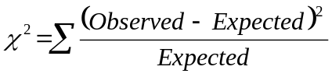

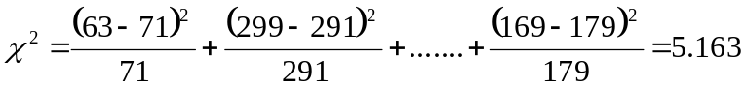
If this is greater than the tabular value of the distribution then the alternative hypothesis is accepted.

The tabular value is given by 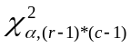 = 7.815 so reject the alternative hypothesis and conclude that there is no evidence in the awarding of development grants.

Note: for Chi-square to be reliable the number in the cell should be greater than 5 and there should not be a multiple of greater than ten between cells.

In EXCEL one can form the table using pivot tables but one has to use formulas to compute the expected values and the Chi-square.

In other computer packages such as SPSS this is easily computed, an example follows.

Analyse>crosstabs>options>statistics

H_{o}: there is no association between variables.
V
H_{a}: there is an association.

e.g. is there an association between gender and minority classification.

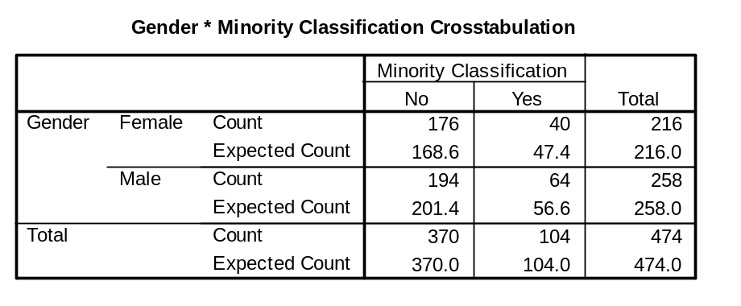

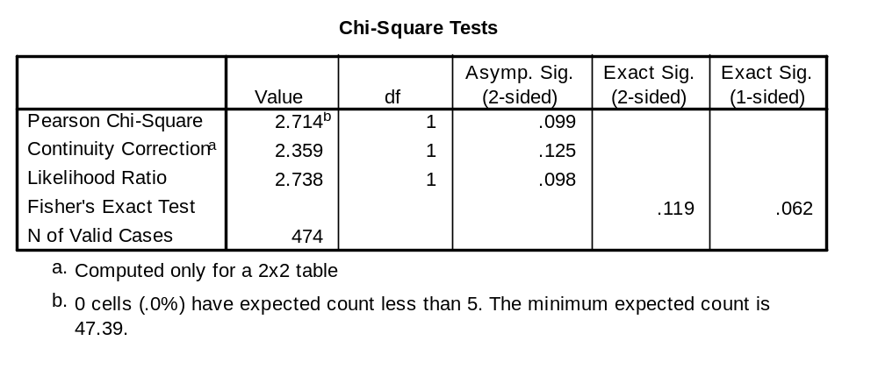
Use this one – so a significant association at the 10% level
Note: the number if the cells needs to be greater than five.
- Summary of Test Procedures.

Requirement | Example of Situation | Test to be used | Comment | Theoretical Test
Compare to a Target | Is the average age of employees more than 40 years? | Use a one sample t - test | Think carefully about hypothesis to be tested.  Continuous data only. | If the data set is more than 30 use a z test
Compare two groups no control | Is male absenteeism less than female absenteeism. | Use independent samples t test | Decide first is variances (standard deviation squared) is similar between groups. Apply either variances assumed equal or variance assumed unequal.  Continuous data only | If the data set is more than 30 use a z test
Compare two groups with one controlled intervention | Test scores before and after training | Use Paired T test | always question the validity that there has been only one intervention.  Continuous data only
Compare more than two groups | Compare amount of waste between four manufacturing plants | Use One Way Analysis of Variance | Continuous data only
To ascertain if there is an association between two categorical variables. | Is there an association between gender and job grade | Contingency tables and Chi square test | All for categorical data

- References

Bryman, A. and Crammer, D., 2004, Quantitative Data Analysis with SPSS 12 and 13: A Guide for Social Scientists, London, Routledge.

M. K. Pelosi, M. K. and T. M. Sandifer, T. M., 2002, Doing Statistics with EXCEL, Chichester, Wiley.

- Exercises

Using the data in the file employ.xls

- Obtain a scatter graph of how salary depends on previous experience

- Obtain a clustered bar chart of percentage in job category by minority status

- Compare salaries for those in an ethnic minority with those who are not. Repeat this for each job category.

- In EXCEL use the formulas = average(range), = median(range) and =stdev(range) to find the median, average and standard deviation for salary and years of education. To find the average of salary go to a cell on the worksheet and enter =average(f2:f475).

- Use pivot tables to compute the mean years of education for job category by ethnic minority.

- In the following table the incidence of crime in California is displayed.

Crime Incidence
Homicide Rape Arson
Berkeley 7 36 28
Oakland 44 192 208
San Francisco 63 294 209
San Jose 13 214 514

Calculate the row percents and interpret the table.
Is there any association between the crime and the region where the crime was committed?

8. The winning times in men’s Olympic runs 1948 to 1972 in seconds for different races are:

Distance
Year 100m 200m 400m 800m 1500m
1948 103 211 462 1092 2298
1952 104 207 459 1092 2252
1956 105 206 467 1077 2212
1960 102 205 449 1063 2156
1964 100 203 451 1051 2181
1968 99 198 438 1043 2149
1972 101 200 447 1059 2163

Apply median polishing and interpret the table produced. Compare the results with median polishing of the logged race times.

9. Use the following data to investigate if there is any association between social class and diagnostic category of psychiatric patients.

 | Diagnosis
Social Class | Neurotic | Depressed | Personality Disorder | Schizophrenic
1 | 45 | 25 | 21 | 18
2 | 10 | 45 | 24 | 22
3 | 12 | 14 | 12 | 10
4 | 3 | 5 | 0 | 6
5 | 2 | 2 | 6 | 2

10. The following table is infant mortality (deaths per 1,000) by region and age of father in the United States in 1964-1966. Apply median polishing and draw conclusions.

Education of Father (in years)
Region <=8 9-11 12 13-15 >=16
North East 25.3 25.3 18.2 18.3 16.3
North Central 32.1 29.0 18.8 24.3 19.0
South 38.8 31.0 19.3 15.7 16.8
West 25.4 21.1 20.3 24.0 17.5

- Find out what the following are used for and how to apply them: Yate’s correction, Goodman and Kruskal’s Lambda statistic, the McNemar test, Gart’s test, Kendell’s Tau, Goodman and Kruskal’s gamma and Somer’s d.

Use the data set in employ.xls

- Is there evidence that the mean number of months in employment is not 80?

- Compare the educational levels of wither or not someone is in a minority.

- Compare the salary of male and female clerical workers

- The percentage market penetration of a product in eight regions before and after advertising are tabulated as follows:

 | Region
Advertising | 1 | 2 | 3 | 4 | 5 | 6 | 7 | 8
Before | 12 | 15 | 10 | 25 | 21 | 44 | 21 | 25
After | 15 | 25 | 8 | 30 | 33 | 49 | 20 | 30

Use a paired t – test to determine if penetration has improved significantly.

16. Conduct a Chi squared test for the following table:

 | Number in job grade
 | Shop floor | Supervisor | Manager
Female | 102 | 20 | 10
Male | 200 | 60 | 25

11.10 APPENDIX Exploratory Data Analysis

EDA Boxplots

Consider the times taken to service photocopiers by two technicians called A and B. The times in minutes are:
Technician A

8, 10, 12, 12, 12, 13, 14, 14, 15, 16, 16, 16, 16, 17, 17, 17, 17, 18, 19, 19, 19, 20, 28
Technician B

9, 11, 11, 14, 15, 16, 16, 17, 17, 17, 18, 18, 19, 19, 19, 19, 19, 19, 20, 20, 21, 21, 23. 23, 24, 24, 24, 25, 25, 26, 27, 29, 30

First obtain the stem and leaf diagrams and the medians and quartiles.

Technician A

Frequency Stem & Leaf

1.00 0 . 8
7.00 1 * 0222344
13.00 1 . 5666677778999
1.00 2 * 0
1.00 Extremes (28)

Stem width: 10.00
Each leaf: 1 case(s)

Now work out the fences

Technician B

Frequency Stem & Leaf

1.00 0 . 9
3.00 1 * 114
14.00 1 . 56677788999999
9.00 2 * 001133444
5.00 2 . 55679
1.00 3 * 0

Stem width: 10.00
Each leaf: 1 case(s)

Summary of Data

 | Time
 | Technician A | Technician B
Q₁ | 13.5 | 17
Median | 16.0 | 19
Q₃ | 17.5 | 24

Lower inner fence is at lower hinge(quartile) - 1.5*hinge spread
Upper inner fence is at upper hinge + 1.5*hinge spread

Lower outer fence is at lower hinge - 3*hinge spread
Upper outer fence is at upper hinge + 3*hinge spread

The hinge spread is the difference between Q₃ and Q₁

If a data point lies in between the inner and outer fences then it is a possible outlier and If the data point exceeds the outer fences then it is a probable outlier

Plot the boxplots

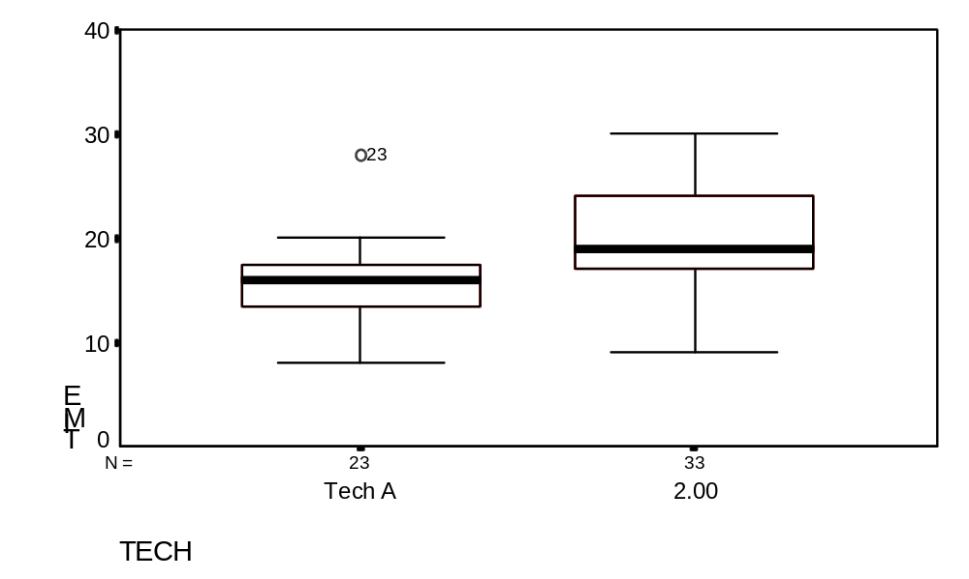
You can add notches as in this case these are computed from:

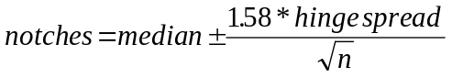

If these do not overlap then there is said to be a significant difference between the groups.

